**AI**

**Artificial Intelligence**

**Corse plan**

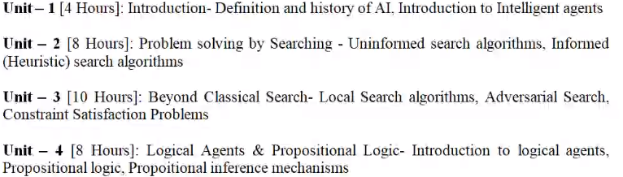

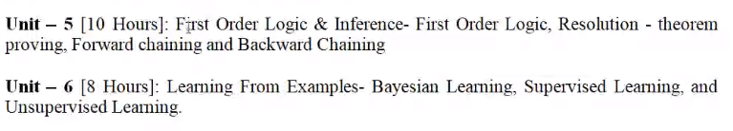

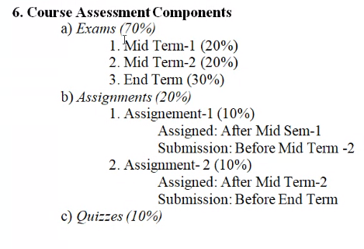

**Lec-1  
07.01.2022**

->History of AI  
->What tasks AI can perform  
->Smart AI can be made if it thinks and act rationally like human brain.  
->Human brain uses memory and computation to perform actions.  
->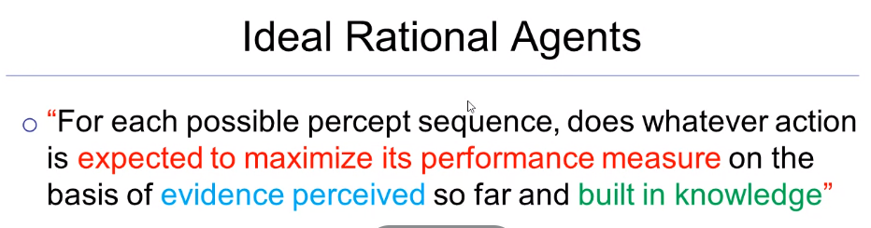

-> Agents percepts through the environment using sensors and perform actions using its actuators  
-> To design a rational agent:-   
 P performance  
 E environment  
 A actuators  
 S sensors